DEPARTMENT OF COMPUTER SCIENCE AND ENGINEERING
QUESTION BANK

Regulation | : | 2023
Course Name | : | DATABASE MANAGEMENT SYSTEMS
Course Code | : | JCS2401
Year / Semester / Branch |  | II/IV/CSE
Unit No | : | 2
Unit Title | : | DESIGN AND NORMALIZATION
No. of Hours | : | 9
Weightage in Exam (%) | : | 20 %

PART A
Q.No. | Questions | Marks | BTL | CO
1. | Define normalization.  Database normalization is the process of organizing tables and attributes using normal forms to reduce redundancy and improve data integrity. It ensures proper dependency enforcement through constraints and is achieved by either creating a new design (synthesis) or refining an existing one (decomposition). | 2 | K1 | CO2
2. | Define BCNF.  A relational schema is in BCNF if all the redundancy based on functional dependency has been removed, although other types of redundancy may still exist. A relational schema R is in Boyce–Codd normal form if and only if for every one of its dependencies X → Y, at least one of the following conditions hold:  X → Y is a trivial functional dependency (Y ⊆ X)  X is a superkey for schema R | 2 | K1 | CO2
3. | Compare Fifth Normal Form (5NF) with Fourth Normal Form (4NF). | 2 | K2 | CO2
  Fourth Normal Form (4NF) | Fifth Normal Form (5NF)
  Eliminates Multivalued Dependencies (MVDs) | Eliminates Join Dependencies (JDs)
  Deals with independent multiple values in a relation | Deals with complex relationships requiring decomposition into smaller tables
  A relation is in 4NF if it has no non-trivial MVDs | A relation is in 5NF if every join dependency is implied by candidate keys
  Removes redundancy caused by multivalued attributes | Removes redundancy caused by improper decomposition
  Easier to understand and apply | More complex and rarely required in practice
  Splits tables to remove MVDs | Further decomposes tables to ensure lossless join without redundancy
  Common in practical database design | Rare, used in highly complex databases
4. | Mention the common pitfalls in relational database design.  - Data redundancy  - Insertion anomaly  - Deletion anomaly  - Update anomaly  - Poor normalization  - Lack of data integrity  - Improper selection of keys | 2 | K1 | CO2
5. | Classify and define the types of participation constraints.  Total: The participation of an entity set E in a relationship set R is said to be total if every entity in E participates in at least one relationship in R.  Partial: if only some entities in E participate in relationships in R, the participation of entity set E in relationship R is said to be partial participation. | 2 | K2 | CO2
6. | Why is lossless decomposition important for normalization?  Decomposition must be lossless. It means that the information should not get lost from the relation that is decomposed. It gives a guarantee that the join will result in the same relation as it was decomposed.  Example: Let's take 'E' is the Relational Schema, With instance 'e'; is decomposed into: E1, E2, E3, . . . . En; With instance: e1, e2, en, If e1 ⋈ e2 ⋈ e3 ⋈ en, then it is called as 'Lossless Join Decomposition'. | 2 | K2 | CO2
7. | List the various types of attributes in ER model.  - Simple attribute.  - Composite attribute.  - Derived attribute.  - Single-value attribute  - Multi-value attribute . | 2 | K1 | CO2
8. | Outline the concept of multi-valued dependency and its characteristics.  When existence of one or more rows in a table implies one or more other rows in the same table, then the Multi-valued dependencies occur. If a table has attributes P, Q and R, then Q and R are multi-valued facts of P. It is represented by double arrow: ->->  For example:  P->->Q  P->->R  In the above case, Multivalued Dependency exists only if Q and R are independent attributes. A table with multivalued dependency violates the 4NF. | 2 | K2 | CO2
9. | State the conditions for lossless decomposition.  Suppose that we decompose the schema R=(A,B,CD,E) into (A,B,C) and (A,D,E), show that this decomposition is a lossless decomposition if the following set F of functional dependencies holds:  A → BC CD → E B → D E→ A  Decomposition is a method used to divide large schema R into number of small relation schemas R1,R2…Rn in such a way that  R1 U R2 U….U R_{n}= R  The decomposition is lossless if either of the following holds: R1 ∩ R2→ R1  R1 ∩ R2 → R2  Here R1 ∩R2 is A which is common attribute and A is a candidate Key. Therefore, the given decomposition is lossless decomposition. | 2 | K2 | CO2
10. | Why is 4NF more desirable than BCNF?  - 4NF is more restrictive than BCNF  - 4NF reduces repetition of information than BCNF  - Every 4NF schema is in BCNF, but there are BCNF schemas that are not in 4NF | 2 | K2 | CO2
11. | Summarize the issues to be considered while developing an ER diagram.  - Use of entity sets Vs attributes.  - Use of entity sets Vs relationship sets.  - Binary Vs N-ary relationship sets.  - Placement of relationship attributes. | 2 | K2 | CO2
12. | List out the extended ER features.  - Specialization  - Generalization  - Attribute Inheritance  - Constraints on Generalizations  - Aggregation  - Reduction to Relation Schemas | 2 | K1 | CO2
13. | Interpret the concept of functional dependency in DBMS.  A functional dependency, denoted by X → Y, between two sets of attributes X and Y that are subsets of R specifies a constraint on the possible tuples that can form a relation state r of R.  The constraint is that, for any two tuples t1 and t2 in r that have t1[X] =t2[X] , they must also have t1[Y] = t2[Y]. | 2 | K2 | CO2
14. | List and define the various forms of trivial dependency  - Trivial − If a functional dependency (FD) X → Y holds, where Y is a subset of X, then it is called a trivial FD. Trivial FDs always hold.  - Non-trivial − If an FD X → Y holds, where Y is not a subset of X, then it is called a non-trivial FD.  - Completely non-trivial − If an FD X → Y holds, where x intersects Y = Φ, it is said to be a completely non-trivial FD. | 2 | K1 | CO2
15. | Mention the reasons for the occurrence of trivial dependencies in relational schemas.  - A trivial functional dependency occurs when the dependent attribute is a subset of the determinant (e.g., A→A); this naturally arises from the definition of functional dependency.  - They exist due to reflexivity rule in normalization, ensuring every attribute functionally determines itself, which helps maintain logical consistency in schemas. | 2 | K1 | CO2
16. | Differentiate Prime and Non-prime attributes. | 2 | K2 | CO2
  Prime Attribute | Non-Prime Attribute
  An attribute that is part of any candidate key | An attribute that is not part of  any candidate key
  Helps uniquely identify tuples (records) | Does not uniquely identify tuples
  Crucial for normalization and key formation | Used for storing additional  Information
  Usually appears in functional dependencies involving keys | Often depends on prime attributes
  Present in candidate/primary key | Not present in any key
17. | Mention the use of a Primary Key .  Primary key is a set of one or more attributes that can uniquely identify record from the relation; it will not accept null values and redundant values. A relation can have only one primary key. | 2 | K1 | CO2
18. | Define super key in DBMS.  A super key is a set of one or more attributes that collectively allows us to identify uniquely an entity in the entity set. | 2 | K1 | CO2
19. | Discuss Domain-Key Normal Form (DKNF) and state the conditions under which a relational schema satisfies DKNF  A relation schema is said to be in DKNF only if all the constraints and dependencies that should hold on the valid relation state can be enforced simply by enforcing the domain constraints and the key constraints on the relation. | 2 | K2 | CO2
20. | Why is it important to eliminate transitive dependencies?  Transitive dependency is a functional dependency which holds by virtue of transitivity. A transitive dependency can occur only in a relation that has three or more attributes. Let A, B, and C designate three distinct attributes (or distinct collections of attributes) in the relation. Suppose all three of the following conditions hold:  - A-> B  - It is not the case that B->A  - B->C  Then the functional dependency A->C (Which follows from 1 and 3 by the axiom of transitivity) is a transitive dependency. | 2 | K2 | CO2

PART B
Q.No. | Questions | Marks | BTL | CO
1. | Discuss in detail about Mapping cardinalities and Enhanced Entity–Relationship (EER). | 16 | K2 | CO2
2. | Explain the Entity–Relationship (ER) model by taking a case study and describe its entities, attributes, relationships, and constraints.  Sample Case Studies:Hospital Management System (or) Railway Ticket Reservation System (or) Library Management System. | 16 | K2 | CO2
3. | Construct an E–R Diagram for the “Restaurant Menu Ordering System”, which will facilitate the food items ordering and services within a restaurant. The entire restaurant scenario is detailed as follows. The Customer is able to view the food items menu, call the waiter, place orders and obtain the final bill through the computer kept in their table. The waiters through their wireless tablet PC are able to initialize a table for customers, control the table functions to assist customers, orders, send orders to food preparation staff (chef) and finalize the customer’s bill. The food preparation staffs (Chefs), with their touch-display interface to the system, are able to view orders sent to the kitchen by waiters. During preparation, they are able to let the waiter know the status of each item, and can send notification when items are completed. The system should have full accountability and logging facilities, and should support supervisor actions to account for exceptional circumstances, such as a meal being refunded or walked out on. | 16 | K3 | CO2
4. | Apply the ER-to-Relational mapping process to convert the given ER diagram into a relational schema. Illustrate each step involved in the mapping, including handling of strong entities, weak entities, relationships (1:1, 1:N, M:N), multivalued attributes, and recursive relationships. Present the final relational schema with appropriate primary and foreign keys.  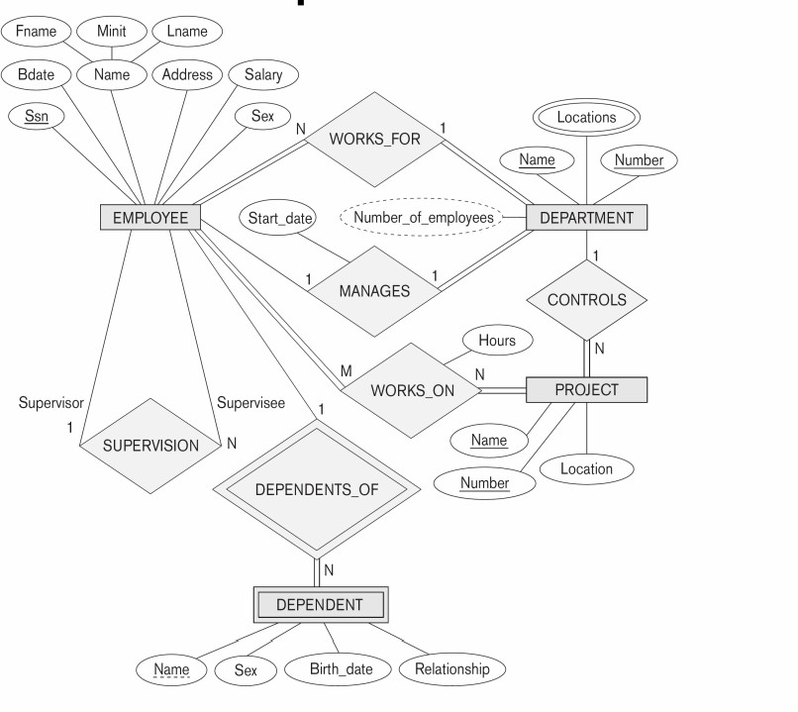 | 16 | K3 | CO2
5. | Explain each of the following normal forms with example.  - First Normal Form  - Second Normal Form  - Third Normal Form  - Boyce-Codd Normal Form | 16 | K2 | CO2
6. | Demonstrate the usage of the following Normal forms in eliminating redundancy and anomalies:  (i) Fourth Normal Form (4NF)  (ii) Multivalued Dependency (MVD)  (iii) Fifth Normal Form (5NF)  (iv) Join Dependency and Lossless Decomposition | 16 | K3 | CO2
7. | Consider the relation:  STUDENT_COURSE (StudentID, StudentName, CourseID, CourseName, Instructor, InstructorPhone)  - Identify the candidate key(s) for the relation.  - Determine the highest normal form of the given relation (1NF, 2NF, or 3NF).  - Normalize the relation up to 3NF, showing all steps clearly.  - Decompose the relation into smaller tables and specify primary keys and foreign keys. | 16 | K3 | CO2
8. | Illustrate full, partial, and transitive dependencies using a sample table. | 16 | K2 | CO2

COURSE FACULTY COURSE COORDINATOR HOD SCRUTINIZER

